Program 3: Working with Maven – Creating a Maven Web Application (WAR)

Procedure
Step 1: Create a Maven Web Application Project
Open the terminal and run the following command:
mvn archetype:generate -DgroupId=com.example -DartifactId=MymavenWebApp \
-DarchetypeArtifactId=maven-archetype-webapp -DinteractiveMode=false
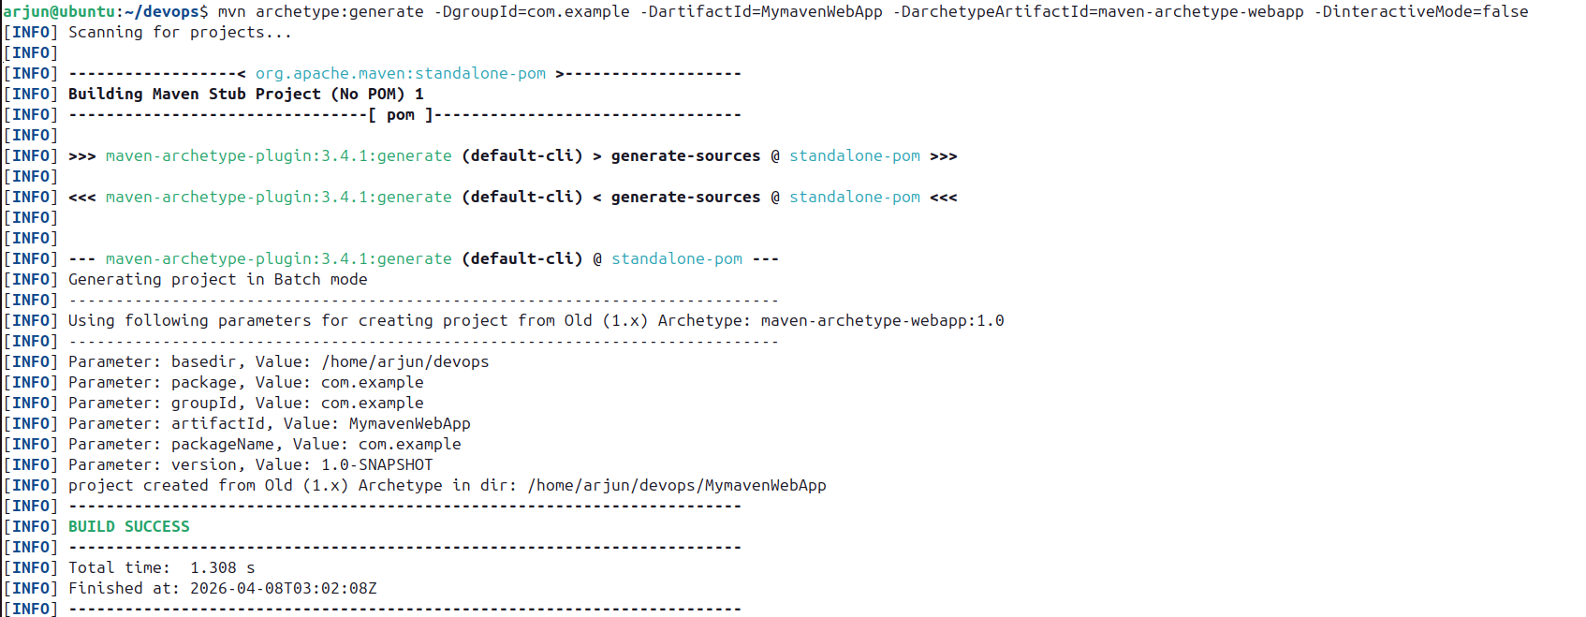

Step 2: Navigate to the Project Directory
cd MymavenWebApp
tree

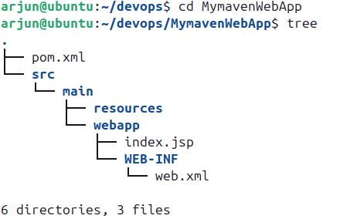

Step 3: Check the index.jsp file

cd src/main/webapp
gedit index.jsp

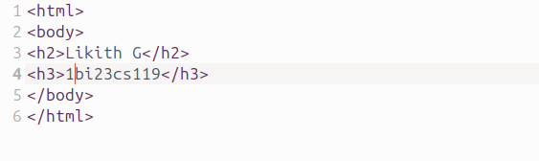

Step 4: Open and Edit pom.xml
gedit pom.xml
pom.xml
<project xmlns="http://maven.apache.org/POM/4.0.0"
xmlns:xsi="http://www.w3.org/2001/XMLSchema-instance"
xsi:schemaLocation="http://maven.apache.org/POM/4.0.0
http://maven.apache.org/maven-v4_0_0.xsd">

<modelVersion>4.0.0</modelVersion>
<groupId>com.example</groupId>
<artifactId>MymavenWebApp01</artifactId>
<packaging>war</packaging>
<version>1.0-SNAPSHOT</version>
<name>MymavenWebApp01 Maven Webapp</name>
<url>http://maven.apache.org</url>

<dependencies>

<dependency>
<groupId>junit</groupId>
<artifactId>junit</artifactId>
<version>3.8.1</version>
<scope>test</scope>
</dependency>

<!-- Servlet API for Java EE -->
<dependency>
<groupId>javax.servlet</groupId>
<artifactId>javax.servlet-api</artifactId>
<version>4.0.1</version>
<scope>provided</scope>
</dependency>

</dependencies>

<build>
<plugins>
<plugin>
<groupId>org.apache.maven.plugins</groupId>
<artifactId>maven-war-plugin</artifactId>
<version>3.4.0</version>
</plugin>
</plugins>
<finalName>MymavenWebApp01</finalName>
</build>

</project>

Go to https://mvnrepository.com, search for the required dependencies (e.g., javax.servlet-api), select the appropriate version and copy the dependency XML snippet. Paste it under the <dependencies> section. Add the maven-war-plugin under the <build> section as shown above.

Step 5: Build the Project

Run the following command to clean and install (compile, test, package):
Maven will compile the source, run tests, and package the application into a WAR file.

mvn clean install
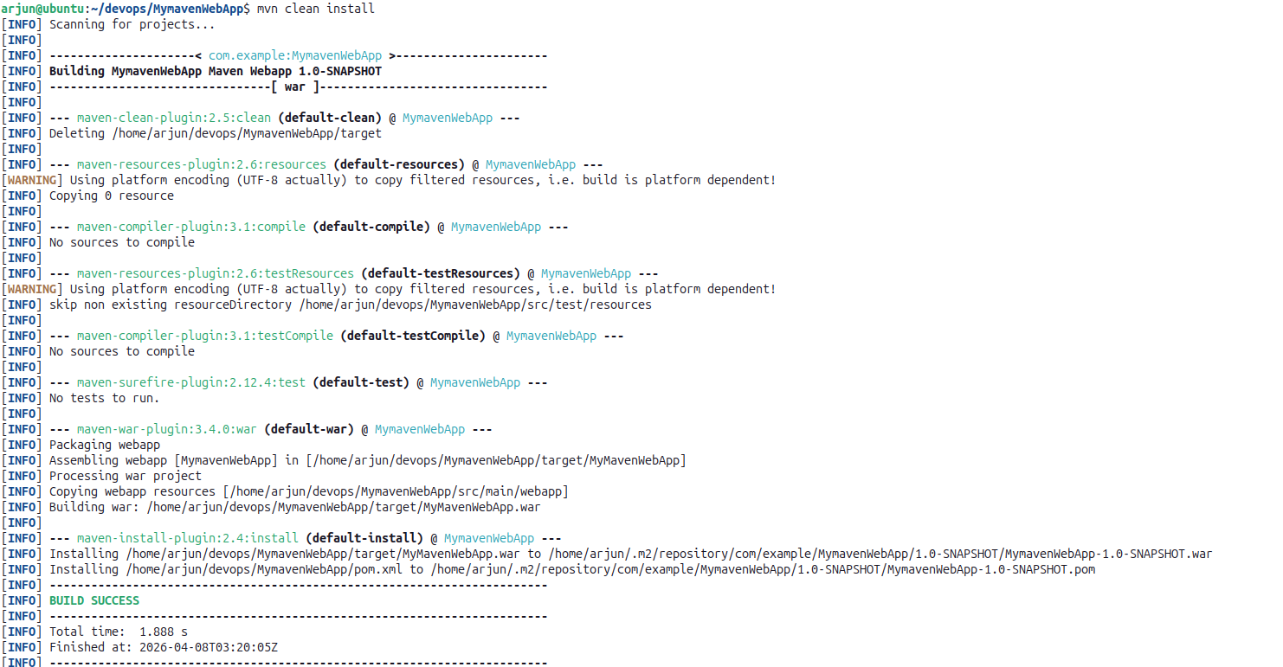

Step 6: Verify the WAR File

After the build completes, run the tree command again to verify the new WAR file:
The target/ directory will now contain the packaged WAR file:
tree
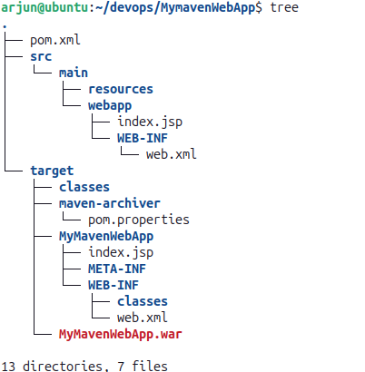

Step 7: Push to Git Repository

Initialize a local Git repository, commit the project, and push it to your remote Git hosting service (e.g., GitHub or GitLab).

Part B: Deploy the Web Application on Apache Tomcat

Step 1: Switch to Root User
Open the terminal and switch to the root user by running:
sudo -i

Step 2: Navigate to the Tomcat bin Directory
Navigate to the Tomcat bin directory where the startup script is located:
cd /opt/tomcat/bin

Step 3: Start the Apache Tomcat Server
Run the startup script to start the Apache Tomcat server:
sh startup.sh

Step 4: Verify Tomcat is Running in the Browser
Open the browser and go to the following URL to confirm the Tomcat server is running:
localhost:9090
The Apache Tomcat welcome page should appear, confirming the server is active.
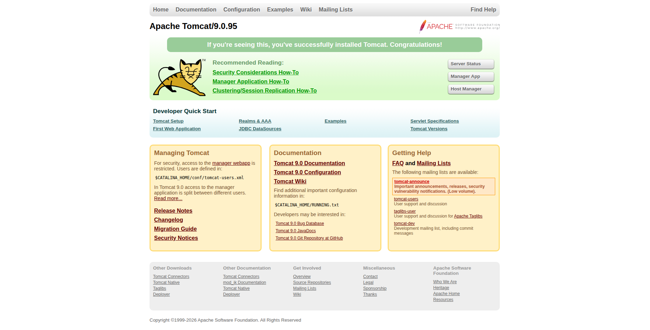

Step 5: Deploy the WAR File to Tomcat webapps
The WAR file created when we ran mvn clean install is located inside the target/ directory of the project. Copy this WAR file and paste it into the Tomcat webapps directory using the file manager address bar:
admin:///opt/tomcat/webapps

Step 6: Reload the Browser and Open Tomcat Manager
Go back to the browser and reload the Tomcat welcome page at localhost:9090. Once the page reloads, click on Manager App and log in with the Tomcat credentials.

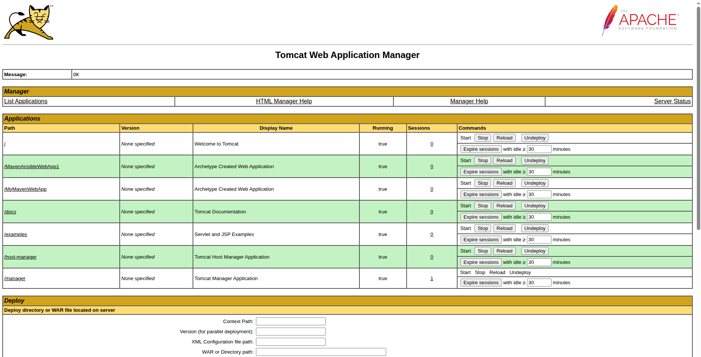

Step 7: Access the Deployed Web Application
In the Tomcat Manager, scroll through the list of deployed applications and find MymavenWebApp. Click on it and it will render the index.jsp HTML code in the browser, confirming the web application has been successfully deployed on the Apache Tomcat server.

